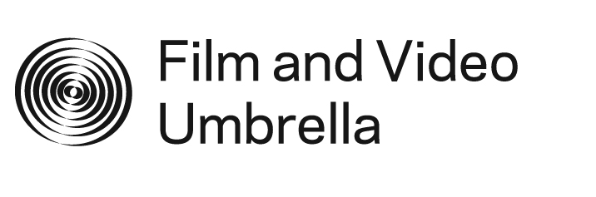

Web Commissions 2011 is a series of new artworks commissioned by Film and Video Umbrella which utilise and engage with online platforms as sites for making, viewing and participating in contemporary art.

The commissioned artists will be working across a range of media, including digital drawings, user generated video content, locative technology and innovative software programmes. The works will exploit and exist in multiple formats, including apps, social networks and filmmaking forums.

Highlighting the collaborative, instantaneous and fluid nature of the internet, these new commissions capture and explore the ever-evolving creative potential of online culture.

For further information and images, please contact Holly Slingsby on 020 7407 7755 or holly@fvu.co.uk

